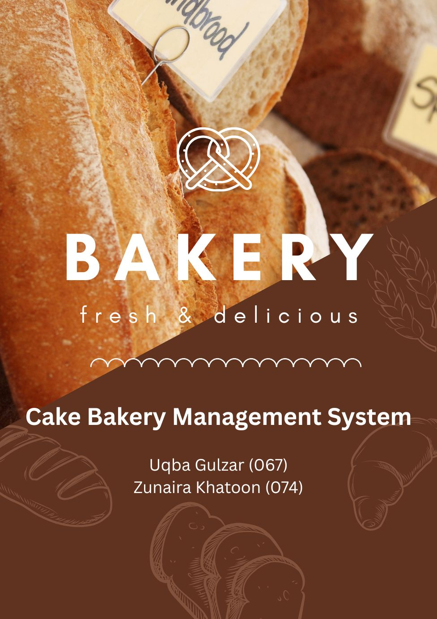**Software Design Description (SDD)**

**Project Title**: *Online Cake Bakery Management System*

**Frontispiece**

* **Date of Issue and Status**: May 3, 2025 – Final Version
* **Issuing Organization**: FJWU
* **Authorship**: Uqba Gulzar, Zunaira Khatoon
* **Change History**:

|  |  |  |
| --- | --- | --- |
| **Date** | **Organization** | **Author** |
| Saturday, May 3, 2025 | FJWU | Uqba Gulzar Zunaira Khatoon |

**Introduction**

### ****Purpose****

The purpose of the Cake Bakery Management System is to provide a structured and object-oriented software solution for managing customer orders and bakery operations. It allows customers to place, edit, and delete cake orders, while enabling the admin to manage customer details, view orders, and access the menu. The system is developed to automate the traditional manual processes of a bakery, ensuring improved efficiency and better user experience.

### ****Scope****

The system includes two primary users: **Customers** and **Admins.** Customers can register their details and perform operations like placing new orders, editing existing ones, or canceling them. Admins are responsible for managing customer data, viewing all placed orders, and accessing the complete menu. The backend is organized using object-oriented programming principles, with abstract classes, declared classes for customer details, and role-specific functionality separated into different classes for better maintainability and scalability.

### ****Context****

This Cake Bakery Management System include object-oriented programming concepts such as **abstraction, inheritance**, and **class-based structure** to a real-world problem. It simulates the core operations of a cake bakery in a digital form, serving as a model system for academic learning or small business use. The system reflects how real-world entities like customers, admins, and orders can be translated into class structures and functionality using code.

### ****Summary****

The Cake Bakery Management System is a class-based software project that encapsulates the key features needed to manage a bakery digitally. It makes use of abstract and concrete classes to define roles and operations, enabling customers to interact with the system and place or manage their orders. The admin has access to customer records, the order list, and the full menu. Overall, the system is structured to be modular, reusable, and aligned with software development best practices using object-oriented principles.

**References**

* [IEEE Std 1016-2009](https://cengproject.cankaya.edu.tr/wp-content/uploads/sites/10/2017/12/SDD-ieee-1016-2009.pdf)

**Glossary**

* **DBMS**: Database Management System
* **MVC**: Model View Controller
* **CRUD**: Create, Read, Update, Delete
* **Stakeholder**: Admin, Customer
* **SDD**: Software Design Document

**Body**

**Identified Stakeholders**

* Admin
* Customer

**Design Viewpoint 1: Use Case View**

**Use Cases**:

**Customer**

* View Menu
* Browse Cakes
* Place Order
* Enter Data
* Edit Order
* Delete Order

**Admin**

* Login
* View Menu
* View all Order

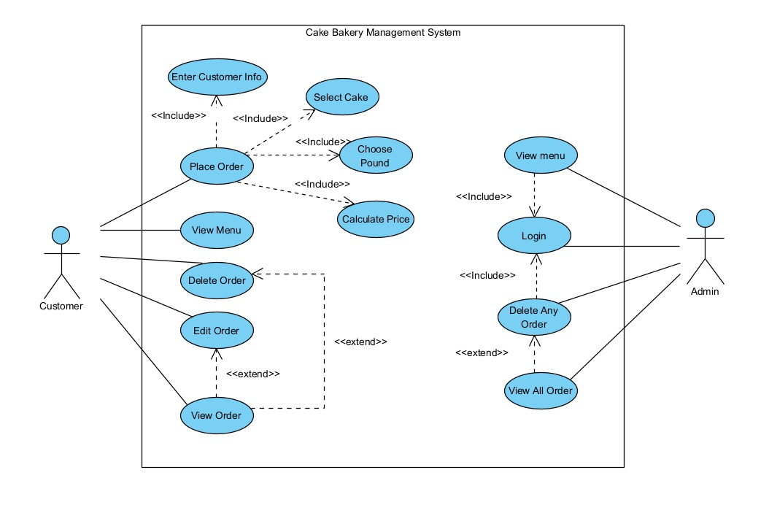

**Use Case: Place Order**

**Use Case Name:** Place Order  
**Scope:** Cake Bakery Management System  
**Level:** User Goal  
**Primary Actor:** Customer  
**Stakeholders and Interests:**

* **Customer:** Wants to successfully place a cake order.
* **Bakery:** Wants accurate order information for timely fulfillment.

**Preconditions:**

* The system is running and accessible.
* Customer has access to the system interface (website or app).

**Postconditions:**

* The order is saved in the system with all relevant information.
* The order details are available for viewing or editing.

**Main Success Scenario:**

1. Customer selects "Place Order."
2. System prompts for customer information.
3. Customer enters personal details (name, contact info, etc.).
4. System prompts customer to select a cake.
5. Customer selects a cake from the menu.
6. System asks for the cake size in pounds.
7. Customer chooses the pound (weight).
8. System calculates the price.
9. System displays the order summary with price.
10. Customer confirms the order.
11. System stores the order and confirms with an order ID.

**Extensions:**

* **2a. Invalid or incomplete customer info:**
  + 2a1. System prompts for correction.
  + 2a2. Use case resumes at Step 3.
* **5a. Cake is not available:**
  + 5a1. System shows out-of-stock message.
  + 5a2. Customer selects another cake or exits.
* **10a. Customer cancels order before confirming:**
  + 10a1. System discards order data.
  + 10a2. Use case ends.

**Special Requirements:**

* System must validate all inputs before proceeding.
* Pricing should be calculated based on dynamic rates.

**Use Case: View Menu**

**Scope:** Cake Bakery Management System  
**Primary Actor:** Customer / Admin  
**Preconditions:** System is accessible.  
**Postconditions:** Menu is displayed.

**Main Success Scenario:**

1. Actor selects "View Menu".
2. System fetches available cakes and options.
3. Menu is displayed with cake names, sizes, and prices.

**Use Case: Edit Order**

**Primary Actor:** Customer  
**Preconditions:** Customer must have placed an order.  
**Postconditions:** Order details are updated.

**Main Success Scenario:**

1. Customer selects “Edit Order”.
2. System shows list of previous orders.
3. Customer selects an order to edit.
4. System displays editable fields (cake type, size, etc.).
5. Customer modifies order details.
6. System recalculates the price.
7. Customer confirms changes.
8. System updates the order.

**Extensions:**

* **3a. No previous orders:** Show “No orders found” message.

**Use Case: Delete Order**

**Primary Actor:** Customer  
**Preconditions:** An order must exist.  
**Postconditions:** Order is deleted.

**Main Success Scenario:**

1. Customer selects “Delete Order”.
2. System displays existing orders.
3. Customer selects an order to delete.
4. System asks for confirmation.
5. Customer confirms.
6. System deletes the order.

**Use Case: View Order**

**Primary Actor:** Customer  
**Preconditions:** Order must exist.  
**Postconditions:** Order details are displayed.

**Main Success Scenario:**

1. Customer selects “View Order”.
2. System lists all placed orders.
3. Customer clicks on one to view full details.
4. System displays order details (cake type, size, price, status).

**Use Case: Login**

**Primary Actor:** Admin  
**Preconditions:** Admin must have credentials.  
**Postconditions:** Admin is logged in.

**Main Success Scenario:**

1. Admin selects “Login”.
2. System prompts for username and password.
3. Admin enters credentials.
4. System validates and logs in the xfadmin.

**Extensions:**

* **3a. Incorrect credentials:**
  + 3a1. System displays error.
  + 3a2. Retry login.

**Use Case: Delete Any Order**

**Primary Actor:** Admin  
**Preconditions:** Admin must be logged in.  
**Postconditions:** Selected order is deleted.

**Main Success Scenario:**

1. Admin logs in.
2. Selects “Delete Any Order”.
3. System displays all customer orders.
4. Admin selects order to delete.
5. System asks for confirmation.
6. Admin confirms.
7. System deletes the order.

**Use Case: View All Orders**

**Primary Actor:** Admin  
**Preconditions:** Admin must be logged in.  
**Postconditions:** All orders are displayed.

**Main Success Scenario:**

1. Admin logs in.
2. Selects “View All Orders”.
3. System fetches and displays list of all orders with customer info.

**Design Viewpoint 2: Logical View**

* **Class Diagram**:

**Classes**:

* Empty
* Declaration
* Customer
* Admin

**Relationships:**

* Inheritance
* Abstraction
* Composition
* Association

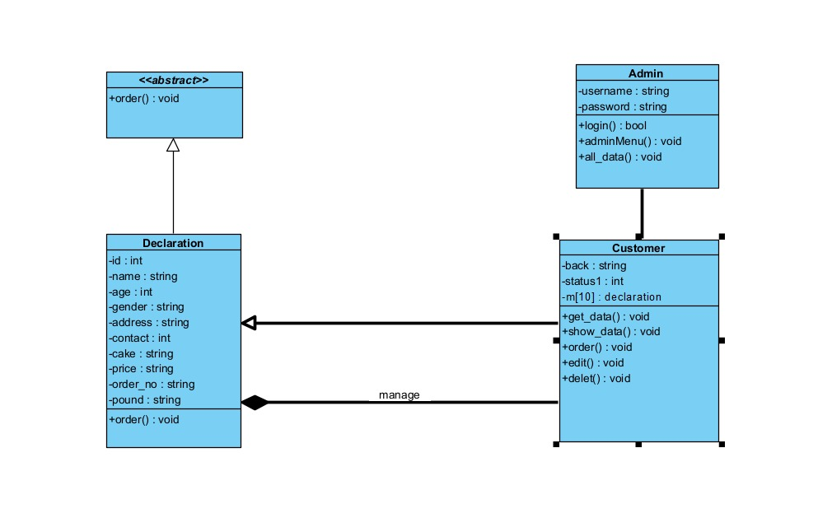

**Design Viewpoint 3: Interaction View**

**Sequence Diagram**

* **Purpose:**

A **Sequence Diagram** is a type of UML (Unified Modeling Language) diagram that models the **flow of interactions** between system components or objects **over time.**

Customer place order

Customer Edit order

Customer Delete order

**Customer:**

* **Place Order**

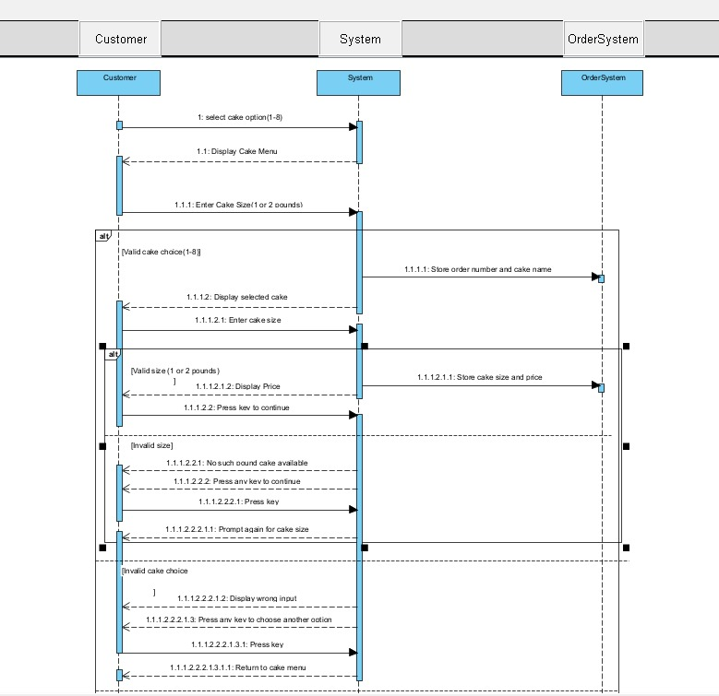

* **Delete Order**

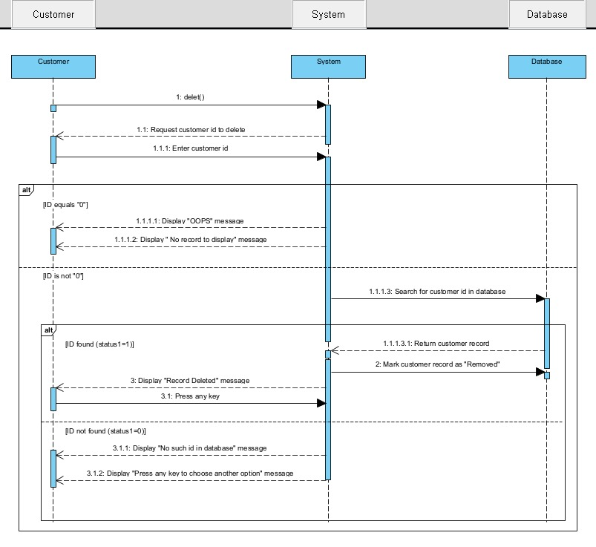

* **Edit Order:**

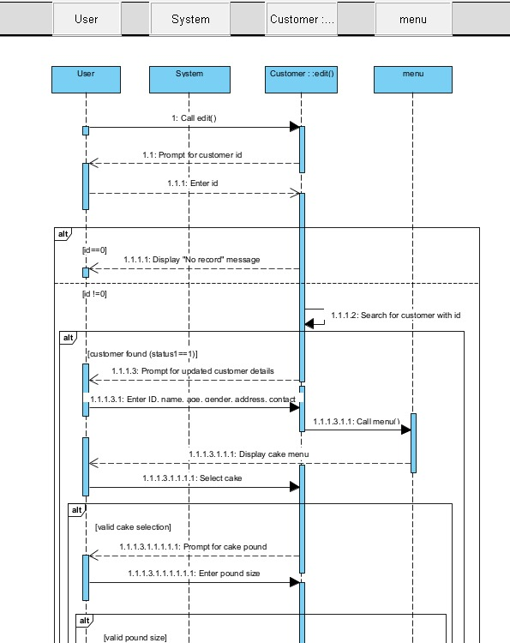

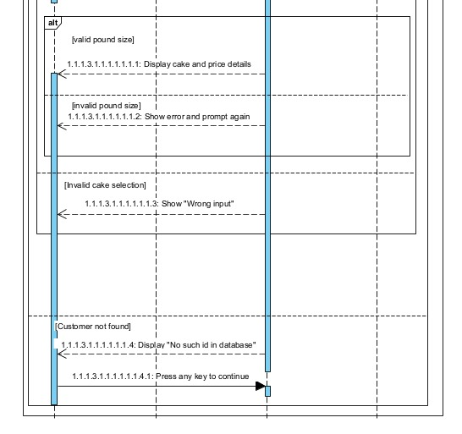

**Admin**

* **Admin View Menu:**

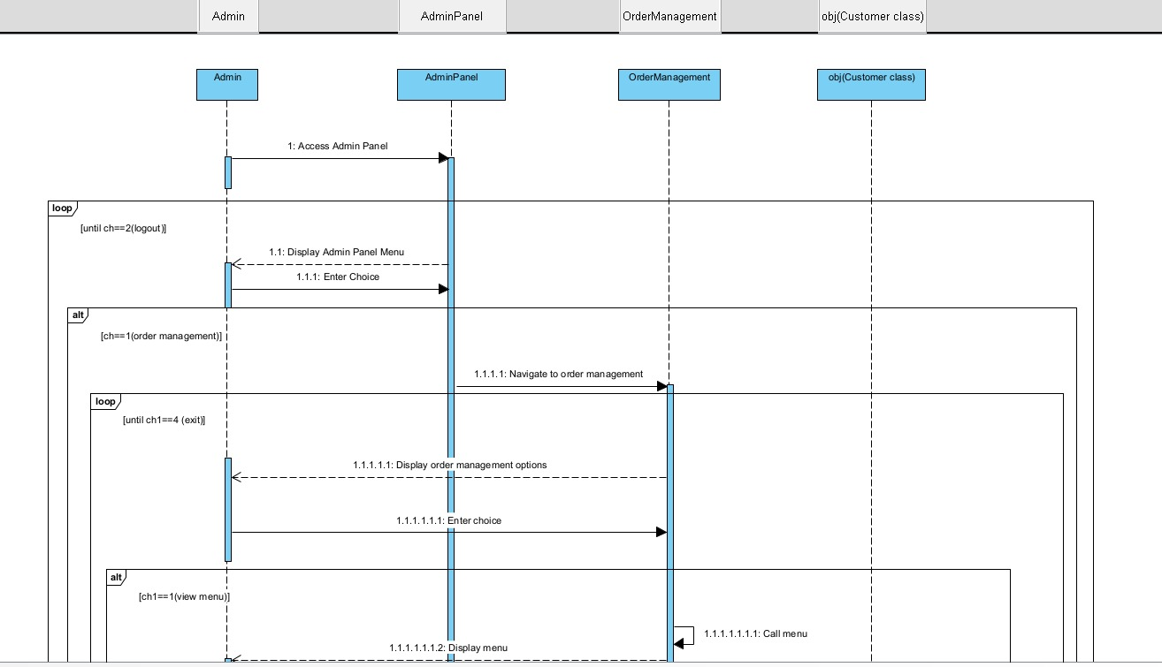

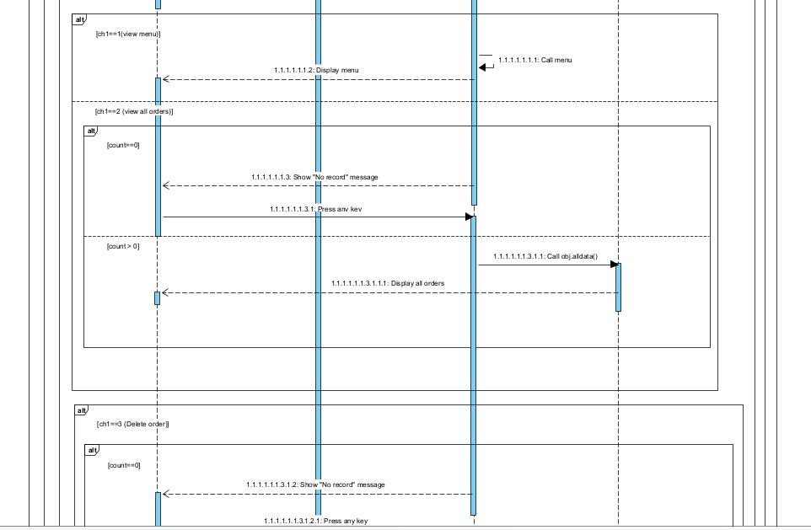

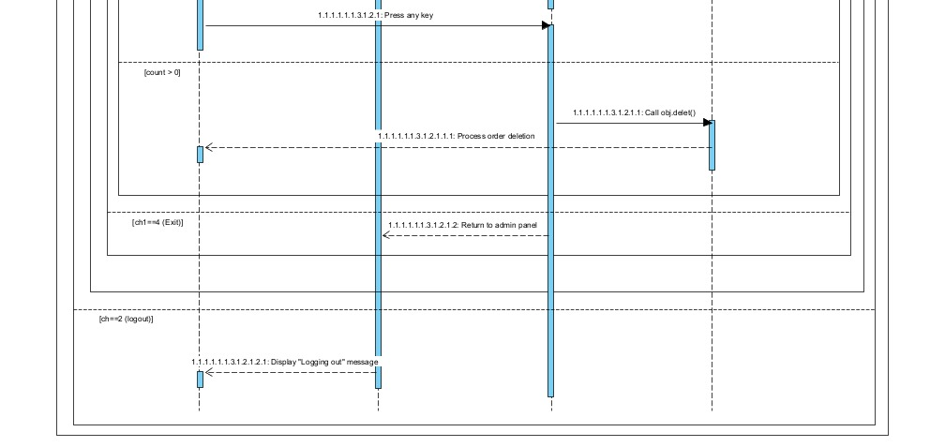

* **Admin Login:**

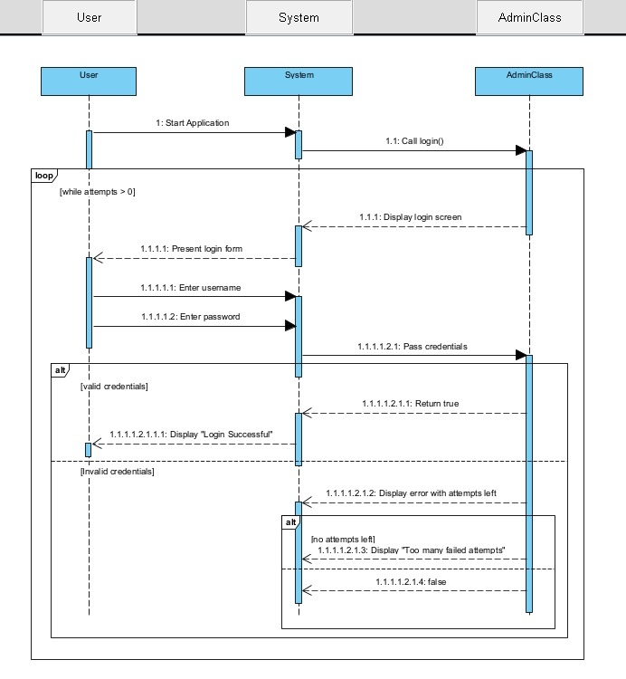

* **Admin View All Order:**

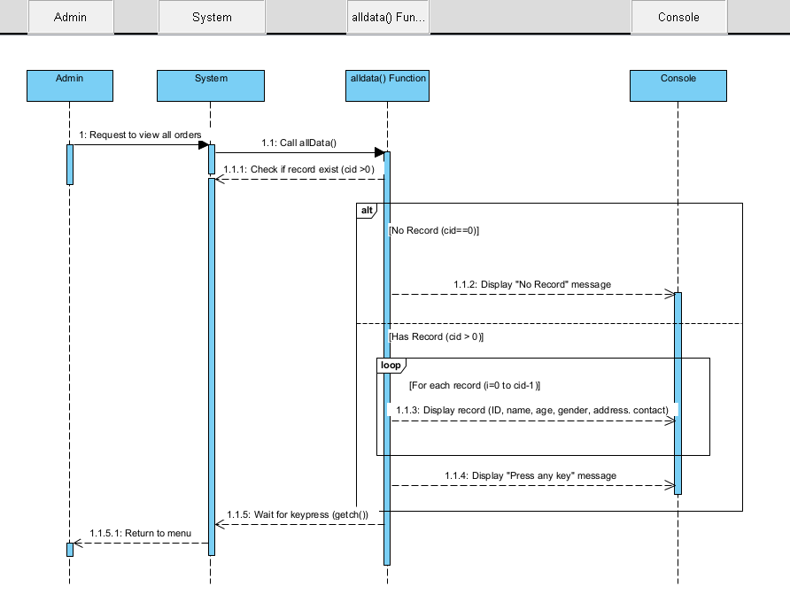

**Design Viewpoint 4: State Dynamic View**

**State Machine Diagram**

* **Purpose:**  
  To show the **different states** an object goes through during its lifecycle, and **what events trigger** state changes.

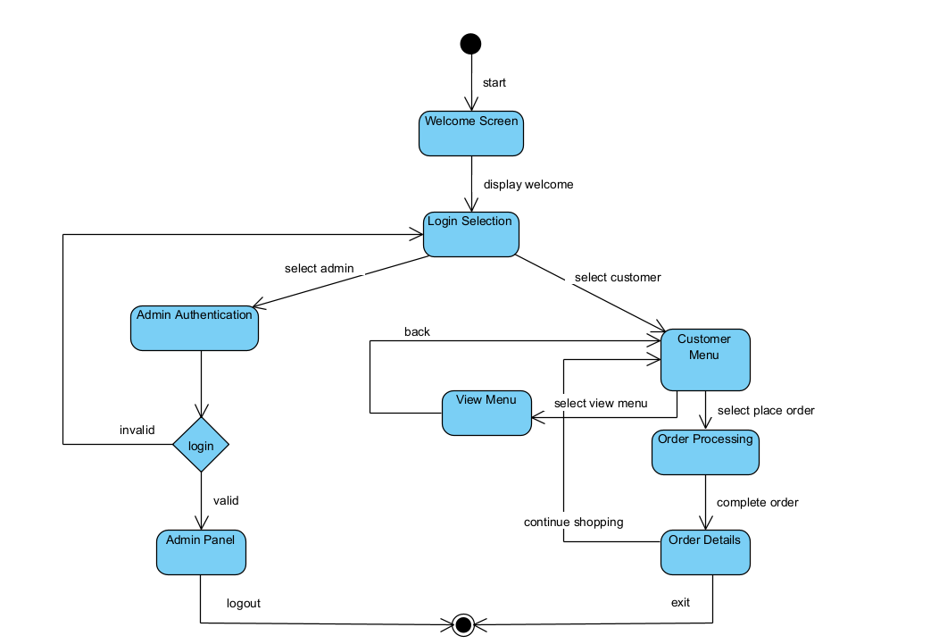

**Design Viewpoint 5: Data View**

**ER Diagram**

**Purpose:**  
To model the **database structure** by showing entities (tables), their **attributes,** and **relationships** between them.

**Entities:**

* **Admin**

**Admin_id**

**Username**

**Password**

* **Customer**

**Id**

**Name**

**Age**

**Gender**

**Address**

**Contact_No**

* **Order**

**Ord_No**

**Cake**

**Pound**

**Price**

**Ord_Type**

* **Cake**

**Cake_id**

**Cake_Name**

**Pound1_Price**

**Pound2_Price**

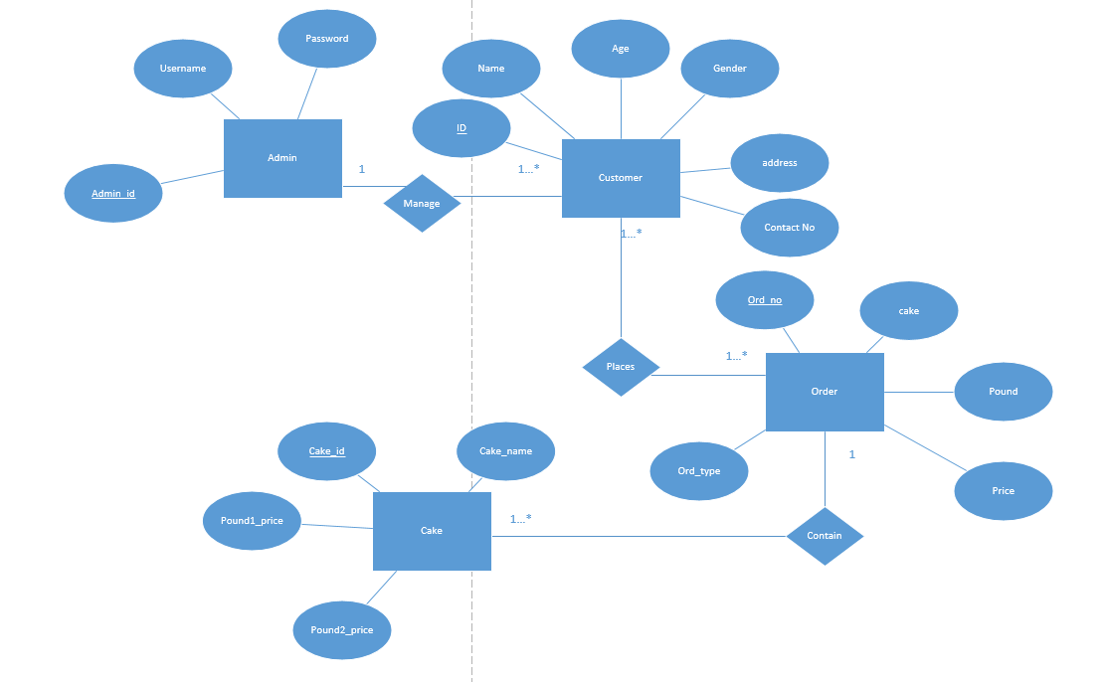

**Design Viewpoint 6: Process View**

**Activity Diagram**

**Purpose:**

Activity Diagrams show how a system behaves dynamically over time

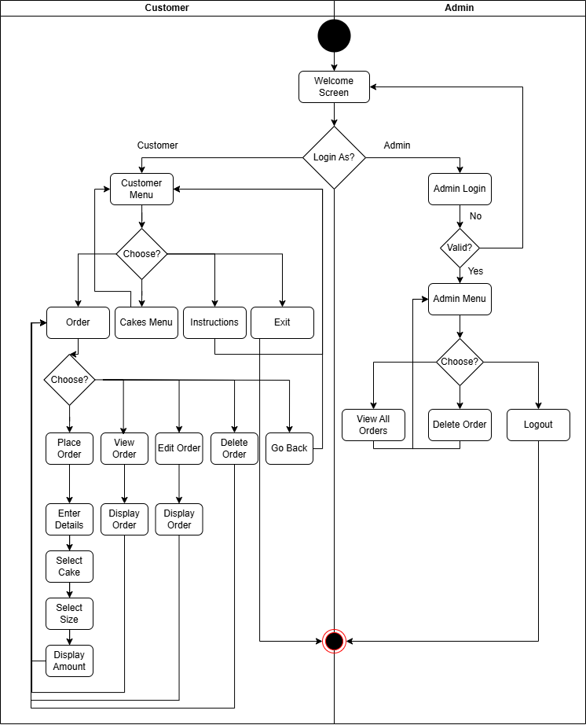

**Design Viewpoint 7: Physical View**

**Deployment Diagram**

**Purpose:**

Shows the physical arrangement of hardware (nodes) and the software components deployed on them, illustrating how a system is distributed across infrastructure.

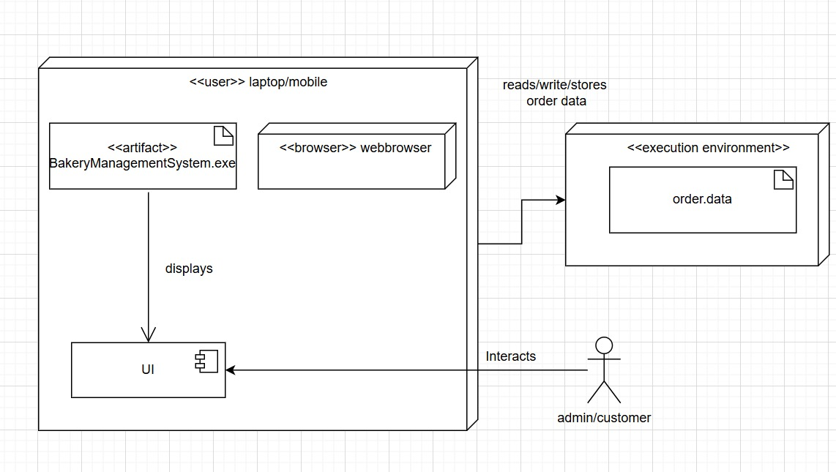

**Design Viewpoint 8: Dependency View**

**Package Diagram**

**Purpose:**

Package diagram illustrates the organization and dependencies of various packages or modules in a system, highlighting their relationships and structure.

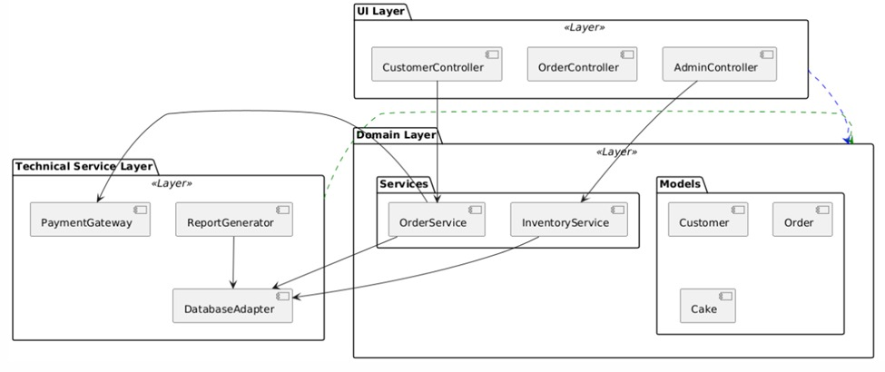

**Design Viewpoint 9: Structure View**

**Composite Structure Diagram**

**Purpose:**

Depicts the internal structure of a class or component, showing its parts, their relationships, and how they collaborate to achieve the component's functionality.

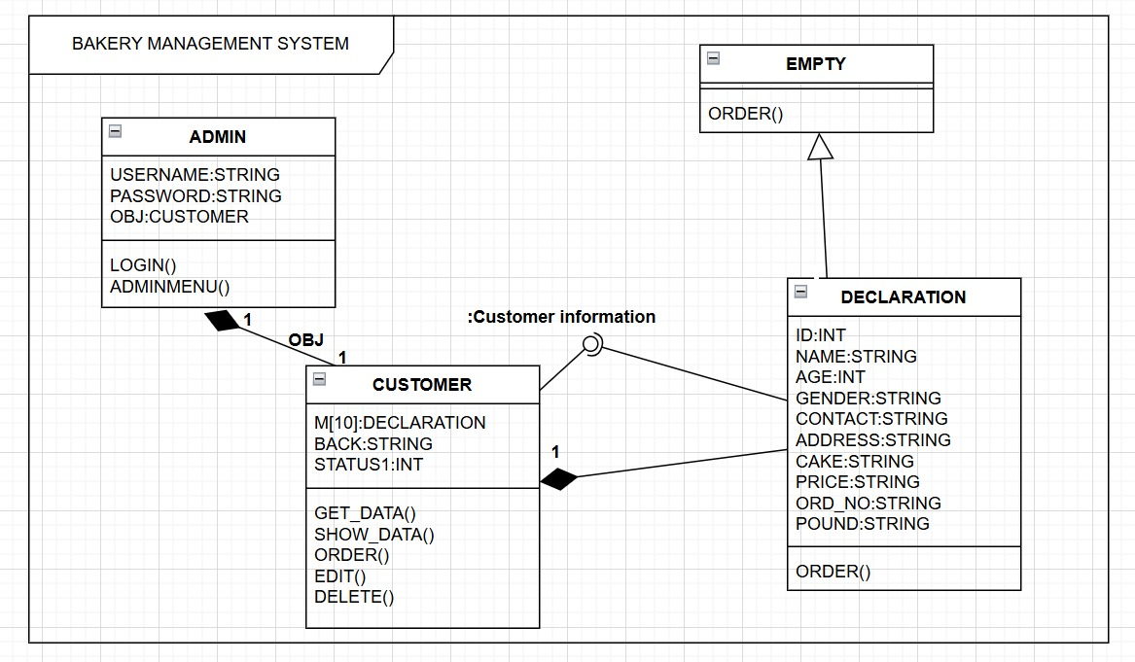

**Design Viewpoint 10: Composition**

**Component Diagram**

* **Purpose:**  
  To show the **high-level structure** of the software system as a set of **components** and how they **interact**

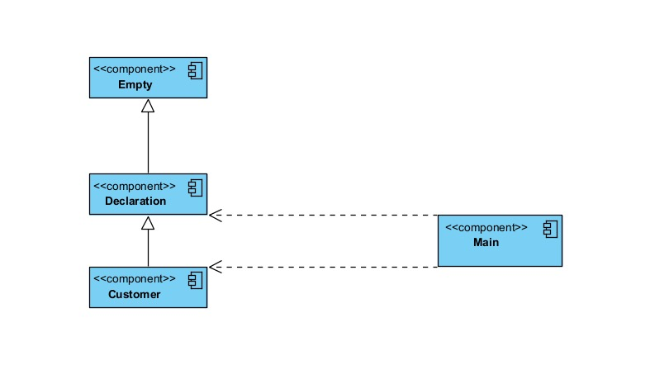

**Design Viewpoints**

**Summary Of Design Viewpoints**

|  |  |  |
| --- | --- | --- |
| **Diagram** | **Viewpoint** | **Focus** |
| Usecase Diagram | Use Case View | Shows interaction between system and users/services. |
| Class Diagram | Logical View | Describes static structure of classes and object organization. |
| Sequence Diagram | Interaction View | Models object communication over time. |
| State Diagram | State Dynamic View | Represents dynamic changes in object states. |
| ER Diagram | Data View | Models persistent data, entities, and their relationships. |
| Activity Diagram | Process View | **Workflow**, business logic, control flow |
| Deployment Diagram | Physical View | |  | | --- | |  |  |  | | --- | | Infrastructure, hardware mapping | |
| Package Diagram | Dependency View | Grouping of model elements and dependencies |
| Composite Structure Diagram | Structure View | Internal structure of classes/components |
| Component Diagram | Composition View | Represents modular parts of the system and their interfaces. |